Special Session Proposal - International Conference on FutureTech 2026 (ICFT)
Title:
Next-Generation Intelligent Algorithms Powered by Quantum Computing (NGIA-QC 2026)
Organizers
 | Dr. G. Jaspher W. Kathrine, Professor, Department of Computer Science and Engineering, Karunya Institute of Technology and Sciences, India  Email: kathrine@karunya.edu  Bio: Dr. G. Jaspher Willsie Kathrine is a Professor and Head of the Department of Computer Science and Engineering, with over 25 years of teaching experience, including 20 years dedicated to research. Her areas of expertise include Cybersecurity, Artificial Intelligence, Data Security, Cyber Forensics, and Healthcare Research. She has been actively involved in mentoring research scholars and is currently guiding eight Ph.D. candidates, of whom three have successfully completed their doctoral degrees under her supervision.
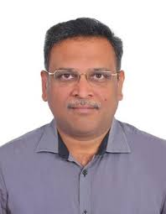 | Dr. J. Dinesh Peter, Professor, Department of Artificial Intelligence and Machine Learning, Karunya Institute of Technology and Sciences, India  Email: dineshpeter@karunya.edu  Bio: Dr. J. Dinesh Peter is an academician with over 20 years of teaching and research experience and has served as the Head of International Affairs since 2017. His research interests include big data, image processing, medical imaging, and computer vision. He has published extensively in reputed international journals and conferences. He has contributed as a session chair, plenary speaker, conference organizer, and editor for Springer proceedings and journal special issues.
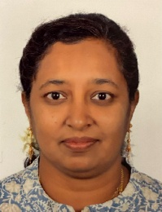 | Dr. S. Salaja, Professor, Department of Computer Science and Engineering, Karunya Institute of Technology and Sciences, India  Email: salaja_cse@karunya.edu  Bio: Dr. Salaja Silas is an academician and researcher with over 20 years of experience specializing in AI, machine learning, intelligent healthcare systems, and emerging technologies like quantum computing and data analytics. She has published widely in leading international journals, holds a patent in AI-based healthcare systems, contributed to ICMR-funded projects, and actively serves as an editor, reviewer, and mentor in interdisciplinary research and innovation.
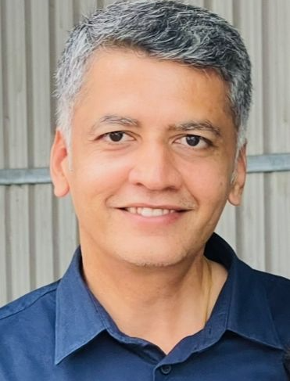 | Dr. R. Venkatesan, Professor, Department of Computer Science and Engineering, Karunya Institute of Technology and Sciences, India  Email: rlvenkei_2000@karunya.edu  Bio: Dr. R. Venkatesan is an academician and researcher with expertise in IoT and cloud computing. He is an IEEE member and active academician involved in mentoring, research publications, and chairing technical sessions.
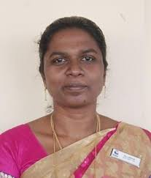 | Dr. Anitha J, Professor, Department of Computer Science and Engineering, Karunya Institute of Technology and Sciences, India  Email: anitha_j@karunya.edu  Bio: Dr. Anitha J is an academic and researcher in specializing intelligent systems and machine learning. She has published numerous research papers in reputed international journals and conferences, focusing on fields such as deep learning, computer vision, and AI applications.
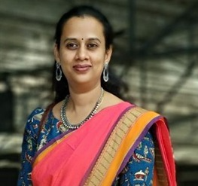 | Dr. M. Mythily, Associate Professor, Department of Computer Science and Engineering, Karunya Institute of Technology and Sciences, India  Email: mythily@karunya.edu  Bio: Dr. M. Mythily is an Associate Professor at Karunya Institute of Technology and Sciences with a Ph.D. from Anna University and over 20 years of experience in academia and industry. Her expertise includes Software Engineering, Design Patterns, Problem-Solving Techniques, and Data Science, with 30+ international publications.
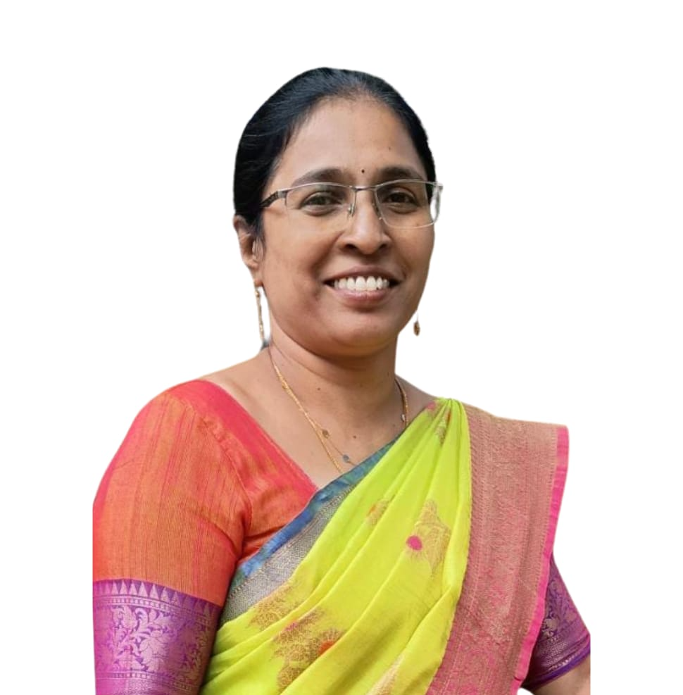 | Dr. D. Brindha, Assistant Professor, Department of Computer Science and Engineering, Karunya Institute of Technology and Sciences, India  Email: brindha@karunya.edu  Bio: Dr. D. Brindha is an experienced academician over two decades of teaching and research expertise. Her work focuses on machine learning, image processing, and data science, with several publications, patents, and conference contributions.

Motivation and Timeliness
Quantum computing is transitioning from theoretical exploration to practical implementation, offering unprecedented computational advantages over classical systems. At the same time, intelligent algorithms—particularly in AI and machine learning—are facing scalability and efficiency bottlenecks when applied to large-scale, real-time, and high-dimensional data problems.
This special session is motivated by the urgent need to bridge quantum computing capabilities with next-generation intelligent algorithms. Recent breakthroughs in quantum hardware, hybrid quantum-classical frameworks, and quantum-inspired algorithms make this an ideal time to explore this convergence.
The session fills a critical gap by:
- Providing a dedicated platform for interdisciplinary research between AI and quantum computing
- Showcasing practical and scalable solutions, beyond purely theoretical models
- Encouraging cross-domain applications in healthcare, cybersecurity, finance, and smart systems
Scope and Topics
In-Scope Topics
- Quantum Machine Learning (QML) algorithms
- Quantum optimization for intelligent systems
- Quantum neural networks and quantum-enhanced deep learning
- Hybrid quantum-classical architectures
- Quantum computing for real-time data analytics
- Quantum algorithms for IoT, cybersecurity, and smart cities
Format Plan
The session will be structured as a Two full-day session including:
- 2 Invited Talks by experts in quantum computing and AI
- Paper Presentations (peer-reviewed submissions aligned with ICFT standards)
Tentative Speaker Plan
1) Dr. S. Sibi Chakravarthy, Professor - SCOPE
Vellore Institute of Technology, Andhra Pradesh.
2) Dr. E. Praveen Kumar, Senior Security Engineer
Equiniti (EQ) X Notified DM, Bengaluru

Expected Audience and Impact
Target Audience
- Researchers in AI, Machine Learning, and Quantum Computing
- Industry professionals in advanced computing and optimization
- Graduate students and early-career researchers
Expected Impact
- Foster collaboration between quantum computing and AI communities
- Encourage novel interdisciplinary research directions
- Provide insights into real-world applications of quantum-enhanced intelligence
- Strengthen ICFT’s position as a platform for emerging technologies
Relevance to ICFT 2026 Tracks
This special session aligns strongly with:
- Track 1: AI, Machine Learning and Edge Intelligence Systems
- Track 2: Circuits, Embedded Systems, IoT and Hardware Security
It complements ICFT’s focus by introducing quantum-enhanced intelligent systems, a rapidly evolving research frontier.
Session Logistics
- Duration: Full-day (6–8 hours)
- Mode: Hybrid (In-person + Virtual presentations)
- Requirements:
  - Usage of in-house facilities
Diversity and Balance Plan
The session will ensure:
- Geographical diversity
- Gender diversity among speakers and panellists
- Balanced representation from academia and industry
- Inclusion of early-career researchers and emerging scholars

